
PB-T2/PSAK/1221/B 25-APR-2022
PRE BOARD EXAMINATION 3- TERM II (2021-2022)
ANSWER KEY
Subject: POLITICAL SCIENCE  Grade: 12 |  | Max. Marks:40  Time:2HRS
Section A
1 | Lohia advocated Chouburja Rajneeti in which he opines four pillars of politics as well as socialism: Centre, Region, District and Village – all are linked with each other. Giving consideration to affirmative action, Lohia argued that the policy of affirmative action should not only be for the downtrodden but also for the women and the non-religious minorities. Based on the premise of Democratic Socialism and Chouburja Rajneeti, Lohia supported a ‘Party of Socialism’ as an attempt of merging all political parties. The Party of Socialism according to Lohia should have three symbols, viz., Spade [prepared to make efforts], Vote [power of voting], and Prison [Willingness to make sacrifices]. |  | 2
2 | On 12 June 1975, Justice Jagmohan Lal Sinha of the Allahabad High Court passed a judgment declaring Indira Gandhi’s election to the Lok Sabha invalid. This order came on an election petition filed by Raj Narain, a socialist leader and a candidate who had contested against her in 1971. The petition, challenged the election of Indira Gandhi on the ground that she had used the services of government servants in her election campaign. The judgment of the High Court meant that legally she was no more an MP and therefore, could not remain the Prime Minister unless she was once again elected as an MP within six months. |  | 2
3 | Jaya Prakash Narayan is known for three key contributions: Fight against Corruption, Principle of Communitarian Socialism and Championing of ‘Total Revolution’. Jaya Prakash Narayan was the first leader in post-independence India who undertook a tirade against corruption through the participation of youth, particularly in Gujarat and Bihar. He advocated the office of Lokpal against corruption. His principle of Communitarian Socialism views India as a society of communities encompassing three key layers, viz., community, region and rashtra – all combining together as an example of true federation. Based on the above principles, Jaya Prakash Narayan advocated transformation of individual, society and state through his call for ‘Total Revolution’. His call for total revolution sought to encompass moral, cultural, economic, political, educational and ecological transformations. His political transformation included the right to recall, the importance of village/mohalla samities in democratic politics, and his call for Upper Ke Log to join political struggle for a clean politics in the country. The essence for transformation according to Jaya Prakash Narayan revolves around ‘Man’ who could be the real catalyst of change in India. |  | 2
4 | Despite the mixed record of the democratic experience, the people in all these countries share the aspiration for democracy. A recent survey of the attitudes of the people in the five big countries of the region showed that there is widespread support for democracy in all these countries. Ordinary citizens, rich as well as poor and belonging to different religions, view the idea of democracy positively and support the institutions of representative democracy. They prefer democracy over any other form of democracy and think that democracy is suitable for their country. |  | 2
5 | While cultural homogenization is an aspect of globalization, the same process also generates precisely the opposite effect. It leads to each culture becoming more different and distinctive. This phenomenon is called cultural heterogenization. This is not to deny that there remain differences in power when cultures interact but instead more fundamentally to suggest that cultural exchange is rarely one way. |  | 2
6 | The European Union Flag The circle of gold stars stands for solidarity and harmony between the peoples of Europe. It has twelve stars, as the number twelve is traditionally the symbol of perfection, completeness, and unity. |  | 2
7 | The Syndicate had played a role in the installation of Indira Gandhi as the Prime Minister by ensuring her election as the leader of the parliamentary party. These leaders expected Indira Gandhi to follow their advise. Gradually, however, Indira Gandhi attempted to assert her position within the government and the party. She chose her trusted group of advisers from outside the party. Slowly and carefully, she sidelined the Syndicate. |  | 2
8 | ASEAN is rapidly growing into a very important regional Organisation. Its Vision 2020 has defined an outward-looking role for ASEAN in the international community. This builds on the existing ASEAN policy to encourage negotiation over conflicts in the region. Thus, ASEAN has mediated the end of the Cambodian conflict, the East Timor crisis, and meets annually to discuss East Asian cooperation. |  | 2
Section B
9  1  2  3  4 | Map based question.  In the given outline map of India 4 states have been marked,Identify the states on the basis of the information given below.  The state where Congress did not get majority in 1967 assembly polls,but formed government with the help of others  The state where Janta Dal got majority in 1977  The state where National Democratic Alliance came to power after the Lok Sabha elections 2004.  The state where C Natarajan became the chief minister in 1967.  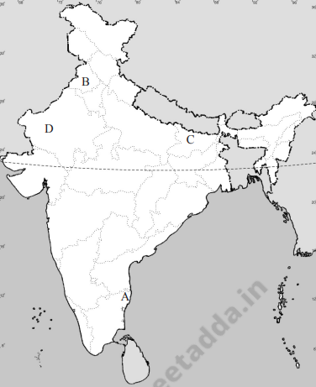  REFER SOURCE |  | 4
10 | Two developments strained this relationship. China annexed Tibet in 1950 and thus removed a historical buffer between the two countries. Initially, the government of India did not oppose this openly. But as more information came in about the suppression of Tibetan culture, the Indian government grew uneasy. The Tibetan spiritual leader, the Dalai Lama, sought and obtained political asylum in India in 1959. China alleged that the government of India was allowing anti-China activities to take place from within India. Refer Pg 72 Book 1 |  | 4
11  1  2 | 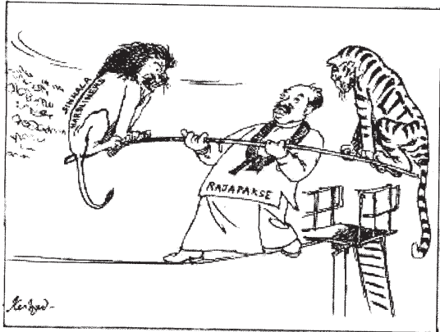  Examine the cartoon and answer the questions  What does lion and the tiger in the cartoon represent?  Which country is depicted in the cartoon and what is the dilemma that the government is in?  REFER SOURCE |  | 4
Section C
12 | One of the debates that has been generated because of contemporary processes of globalization relates to its ongoing political impact. How does globalization affect traditional conceptions of state sovereignty? There are at least three aspects that we need to consider when answering this question. Refer pg139 Book 2  OR  Critics of globalization make a variety of arguments. Those on the left argue that contemporary globalization represents a particular phase of global capitalism that makes the rich richer (and fewer) and the poor poorer. Weakening of the state leads to a reduction in the capacity of the state to protect the interest of its poor. Critics of globalization from the political right express anxiety over the political, economic and cultural effects. Refer Pg 145 Book2 |  | 6
13 | The period after 1989 is seen sometimes as the period of decline of Congress and rise of BJP. If you want to understand the complex nature of political competition in this period, you have to compare the electoral performances of the Congress and the BJP. Refer Pg 189 Book 1  OR  The Constitution simply mentioned ‘internal disturbances’ as the reason for declaring Emergency. Before 1975, Emergency was never proclaimed on this ground. We have noted that agitations were going on in many parts of the country. Was this reason enough for declaring Emergency? Refer Pg 113 Book |  | 6
***

